Mysql task
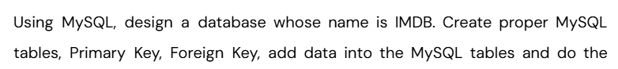

create database IMDB;
use IMDB;

-- Movies
create table Movies (
movie_id INT PRIMARY KEY AUTO_INCREMENT,
title VARCHAR(200),
release_year INT
);

insert into Movies (title, release_year) values
('Baahubali: The Beginning', 2015),
('Enthiran', 2010),
('Vikram', 2022),
('Kaithi', 2019),
('Ponniyin Selvan: Part 1', 2022);

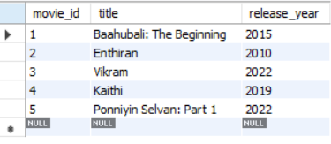

-- Media (Video/Image linked to Movie)
create table Media (
media_id INT PRIMARY KEY AUTO_INCREMENT,
movie_id INT,
media_type ENUM('Video','Image'),
url VARCHAR(255),
FOREIGN KEY (movie_id) REFERENCES Movies(movie_id)
);

insert into Media (movie_id, media_type, url) values
(1, 'Video', 'http://trailers.com/baahubali.mp4'),
(1, 'Image', 'http://images.com/baahubali.jpg'),
(2, 'Video', 'http://trailers.com/enthiran.mp4'),
(2, 'Image', 'http://images.com/enthiran.jpg'),
(3, 'Video', 'http://trailers.com/vikram.mp4'),
(3, 'Image', 'http://images.com/vikram.jpg'),
(4, 'Video', 'http://trailers.com/kaithi.mp4'),
(5, 'Video', 'http://trailers.com/ps1.mp4'),
(5, 'Image', 'http://images.com/ps1.jpg');



-- Genres
create table Genres (
genre_id INT PRIMARY KEY AUTO_INCREMENT,
genre_name VARCHAR(100)
);
insert into Genres (genre_name) values
('Action'),
('Drama'),
('Thriller'),
('Historical'),
('Science Fiction');


Movie-Genre relationship (many-to-many)
create table MovieGenres (
movie_id INT,
genre_id INT,
PRIMARY KEY(movie_id, genre_id),
FOREIGN KEY (movie_id) REFERENCES Movies(movie_id),
FOREIGN KEY (genre_id) REFERENCES Genres(genre_id)
);

insert into MovieGenres (movie_id, genre_id) values
(1, 1), (1, 2),
(2, 5),
(3, 1), (3, 3),
(4, 1), (4, 3),
(5, 2), (5, 4);

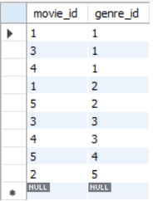

-- Users
create table Users (
user_id INT PRIMARY KEY AUTO_INCREMENT,
name VARCHAR(100)
);

insert into Users (name) values
('Arun'),
('Priya'),
('Karthik'),
('Divya');
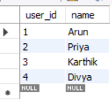

-- Reviews
create table Reviews (
review_id INT PRIMARY KEY AUTO_INCREMENT,
movie_id INT,
user_id INT,
review_text TEXT,
rating INT,
FOREIGN KEY (movie_id) REFERENCES Movies(movie_id),
FOREIGN KEY (user_id) REFERENCES Users(user_id)
);

insert into Reviews (movie_id, user_id, review_text, rating) values
(1, 1, 'Epic visuals and storytelling!', 5),
(2, 2, 'Rajinikanth was amazing!', 4),
(3, 3, 'Intense and gripping thriller.', 5),
(4, 4, 'Lokesh Kanagaraj delivers again.', 4),
(5, 1, 'Beautiful adaptation of Kalki novel.', 5);


-- Artists
create table Artists (
artist_id INT PRIMARY KEY AUTO_INCREMENT,
name VARCHAR(100)
);

insert into Artists (name) values
('Rajinikanth'),
('Kamal Haasan'),
('Suriya'),
('Karthi'),
('Aishwarya Rai Bachchan');
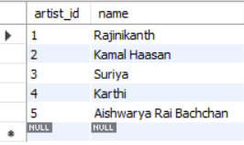

-- Skills
create table Skills (
skill_id INT PRIMARY KEY AUTO_INCREMENT,
skill_name VARCHAR(100)
);

insert into Skills (skill_name) values
('Acting'),
('Dancing'),
('Singing'),
('Stunts');


-- Artist-Skill relationship
create table ArtistSkills (
artist_id INT,
skill_id INT,
PRIMARY KEY(artist_id, skill_id),
FOREIGN KEY (artist_id) REFERENCES Artists(artist_id),
FOREIGN KEY (skill_id) REFERENCES Skills(skill_id)
);

insert into ArtistSkills (artist_id, skill_id) values
(1, 1), (1, 2),
(2, 1), (2, 3),
(3, 1), (3, 4),
(4, 1), (4, 4),
(5, 1), (5, 2);

-- Roles in Movies
create table Roles (
role_id INT PRIMARY KEY AUTO_INCREMENT,
role_name VARCHAR(100)
);

insert into Roles (role_name) values
('Hero'),
('Villain'),
('Supporting Actor'),
('Director');

-- Artist performing roles in Movies
create table MovieRoles (
movie_id INT,
artist_id INT,
role_id INT,
PRIMARY KEY(movie_id, artist_id, role_id),
FOREIGN KEY (movie_id) REFERENCES Movies(movie_id),
FOREIGN KEY (artist_id) REFERENCES Artists(artist_id),
FOREIGN KEY (role_id) REFERENCES Roles(role_id)
);

insert into MovieRoles (movie_id, artist_id, role_id) values
(2, 1, 1),
(3, 2, 1),
(4, 4, 1),
(5, 5, 1),
(1, 3, 2);



-- 1. movie should have multiple media
select Movies.title AS movie,
Media.media_type,
Media.url as media_url
from Movies
join Media
on Movies.movie_id = Media.movie_id
order by Movies.title, Media.media_type;



-- 2.Movie can belong to multiple genre

select Movies.title AS movie,
Genres.genre_name
from Movies
join MovieGenres
on Movies.movie_id = MovieGenres.movie_id
join Genres
on MovieGenres.genre_id = Genres.genre_id
order by Movies.title, Genres.genre_name;



-- 3. Movie can have multiple review and review can belong to user
select Movies.title, Users.name AS reviewer, Reviews.review_text, Reviews.rating
from Movies
join Reviews
on Movies.movie_id = Reviews.movie_id
join Users
on Reviews.user_id = Users.user_id
order by Movies.title, Users.name;


-- 4. Artist can have multiple skills
select Artists.name AS artist, Skills.skill_name
from Artists
join ArtistSkills
on Artists.artist_id = ArtistSkills.artist_id
join Skills
on ArtistSkills.skill_id = Skills.skill_id
order by Artists.name, Skills.skill_name;


select Artists.name AS artist, count(Skills.skill_id) AS total_skills
from Artists
join ArtistSkills
on Artists.artist_id = ArtistSkills.artist_id
join Skills
on ArtistSkills.skill_id = Skills.skill_id
group by Artists.name;

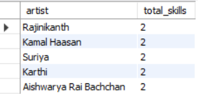

-- 5. Artist can perform multiple role in a single film
select Movies.title AS movie,
Artists.name AS artist,
Roles.role_name
from Movies
join MovieRoles
on Movies.movie_id = MovieRoles.movie_id
joib Artists
on MovieRoles.artist_id = Artists.artist_id
join Roles
on MovieRoles.role_id = Roles.role_id
order by Movies.title, Artists.name, Roles.role_name;



select Movies.title AS movie,
Artists.name AS artist,
(select group_concat(Roles.role_name SEPARATOR ', ')
from MovieRoles
join Roles
on MovieRoles.role_id = Roles.role_id
where MovieRoles.movie_id = Movies.movie_id
and MovieRoles.artist_id = Artists.artist_id) AS roles
from Movies
join MovieRoles
on Movies.movie_id = MovieRoles.movie_id
join Artists
on MovieRoles.artist_id = Artists.artist_id
order by Movies.title, Artists.name;



